**Beginner Level**

1. What is NumPy, and why is it used in Python?

**NumPy (Numerical Python)** is a powerful **open-source library** in Python used for **numerical computing**. It provides support for **multi-dimensional arrays**, **mathematical functions**, **linear algebra**, and **random number generation**.

✔ **It is faster than Python lists** due to **vectorization, broadcasting, and optimized memory usage**.

1. How do you install NumPy, and how do you import it in a Python script?
2. What is the difference between a Python list and a NumPy array?

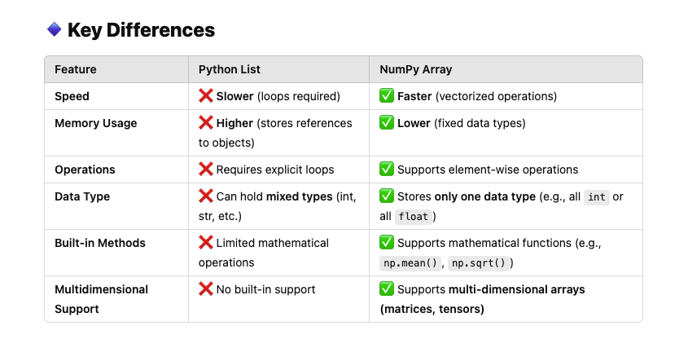

1. How do you create a NumPy array from a list?

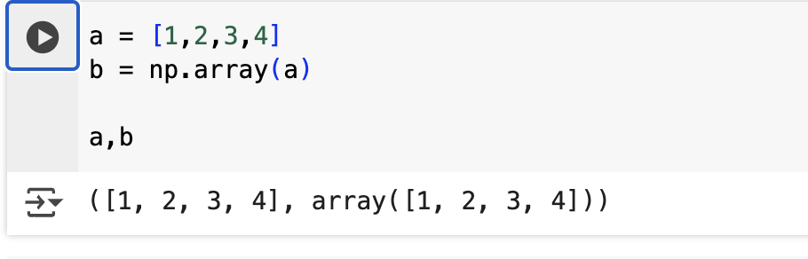

### In NumPy, the **dtype (<U21>)** indicates that the array is of **Unicode string type** with a **maximum length of 21 characters**.

1. What is the difference between np.array() and np.asarray()?

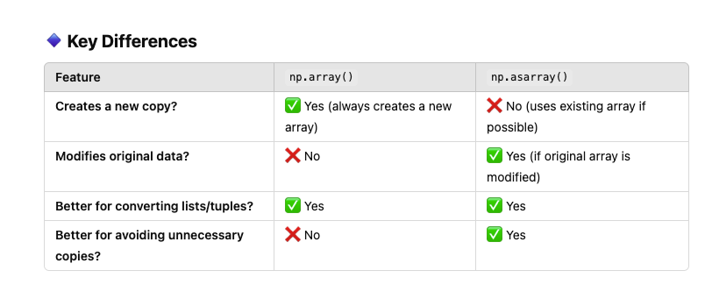

1. How do you check the shape, size, and data type of a NumPy array?

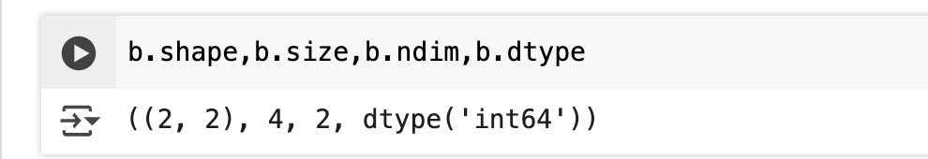

1. How do you generate a NumPy array with a range of numbers?
2. Explain the difference between np.arange() and np.linspace().

**np.arange(start, stop, step)**

**np.linspace(start, stop, num)** : default stepsize 50

Arange and linspace are used to create a list of elements. Specifying the start, end and the difference in case of arange, while specifying the no. of elements in case of linspace.

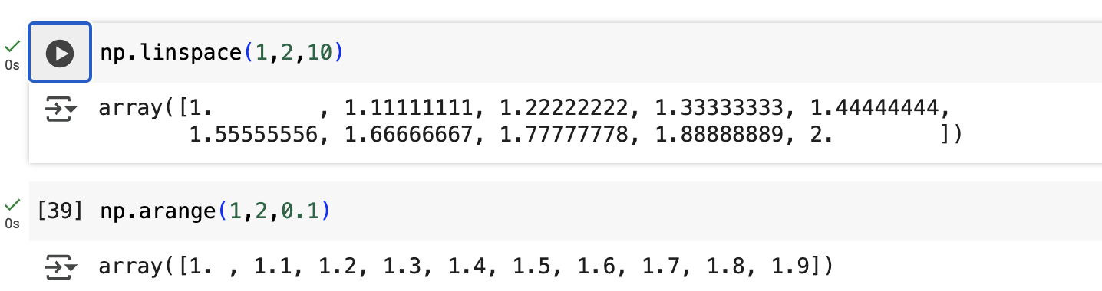

9. How do you create a NumPy array with all zeros or ones?

1. What is the difference between np.zeros(), np.ones(), and np.full()?

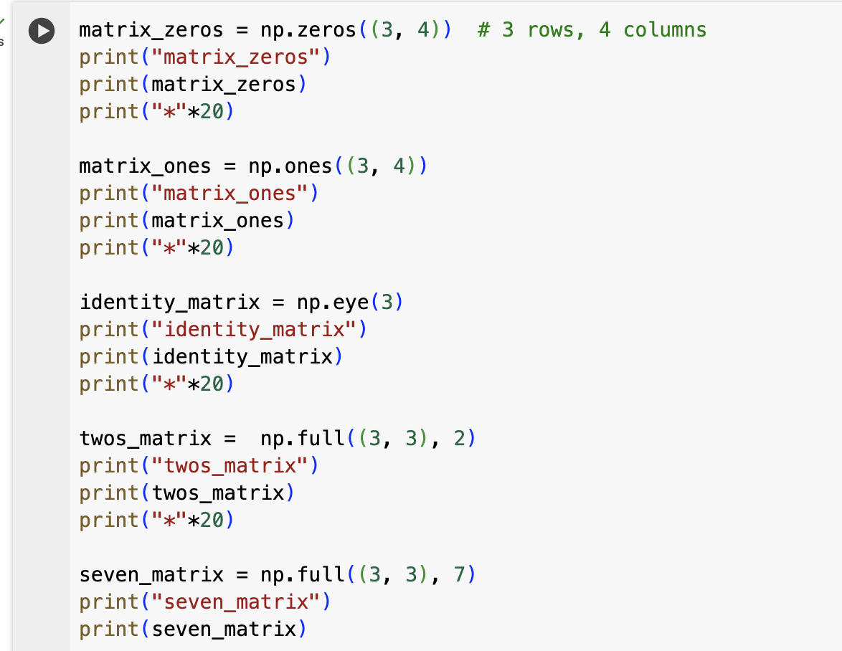

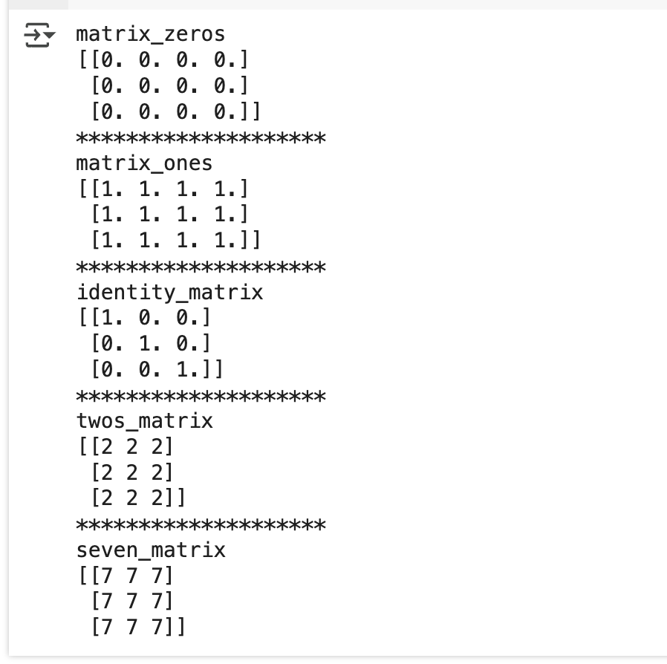

**Intermediate Level**

1. How do you change the shape of a NumPy array?

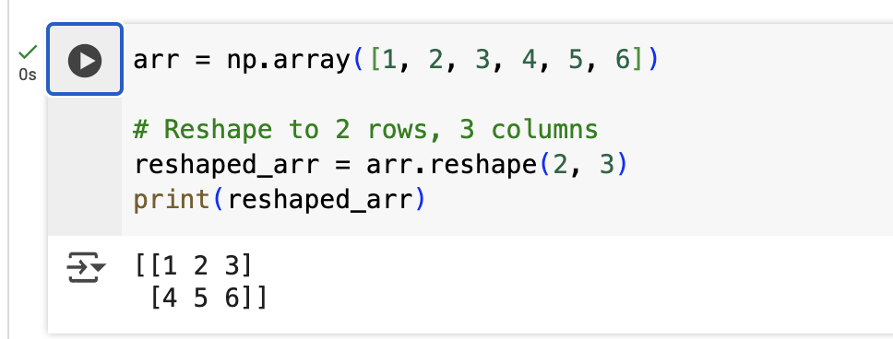

1. What is broadcasting in NumPy?

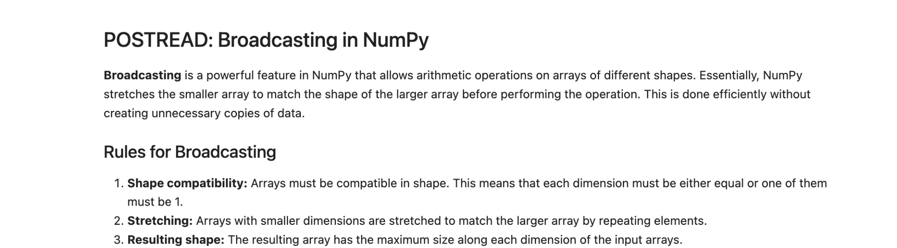



1. How do you perform element-wise operations in NumPy?

**NumPy automatically applies operations element-wise on arrays without requiring loops. This is called vectorization, making computations much faster than Python loops.**

1. What is the difference between shallow copy (view()) and deep copy (copy()) in NumPy?

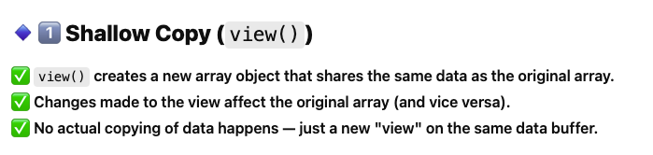

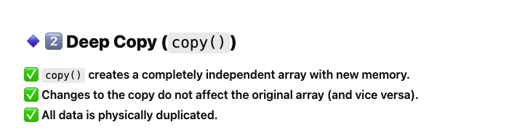

1. How do you filter elements in a NumPy array using boolean indexing?

1. How do you stack NumPy arrays vertically and horizontally?

1. What is np.concatenate(), and how does it differ from np.vstack() and np.hstack()?
2. How do you find the mean, median, standard deviation, and variance of an array?

**np.mean(), np.median(), np.std(), np.var()**

1. How do you find the unique elements in a NumPy array?

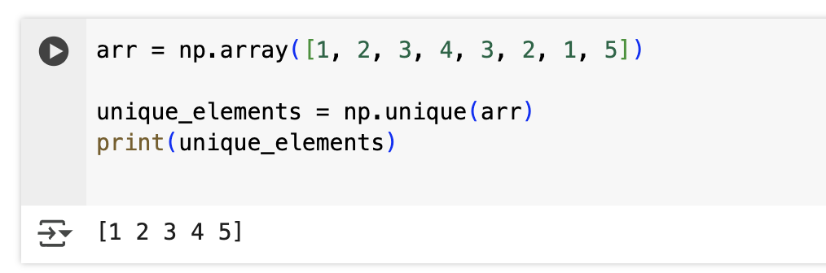

1. How do you perform matrix multiplication in NumPy?

1. What is np.dot() vs. @ operator in NumPy?

1. How do you compute the inverse and determinant of a matrix?
2. How do you find the eigenvalues and eigenvectors of a matrix?
3. How do you sort a NumPy array?
4. Explain np.where() with an example.

**Advanced Level**

1. What is the difference between np.linalg.solve() and np.linalg.inv()?
2. How do you work with structured arrays in NumPy?
3. How can you optimize performance using NumPy's vectorization?
4. How do you generate random numbers in NumPy?
5. What is the difference between np.random.rand(), np.random.randn(), and np.random.randint()?
6. How do you shuffle an array randomly using NumPy?
7. What is memory layout in NumPy (C-order vs. F-order)?
8. How do you handle NaN (Not a Number) values in NumPy?
9. What is the difference between np.nan and None?
10. How do you perform element-wise operations on two arrays with different shapes?
11. How does NumPy handle large datasets efficiently?
12. How do you optimize NumPy operations using numba or cython?
13. How does NumPy interact with Pandas and SciPy?
14. Explain the use of np.meshgrid().
15. How do you convert a NumPy array to a different data type?